World Congress Abstract Submission Template
To be submitted at rwuaconference@gmail.com
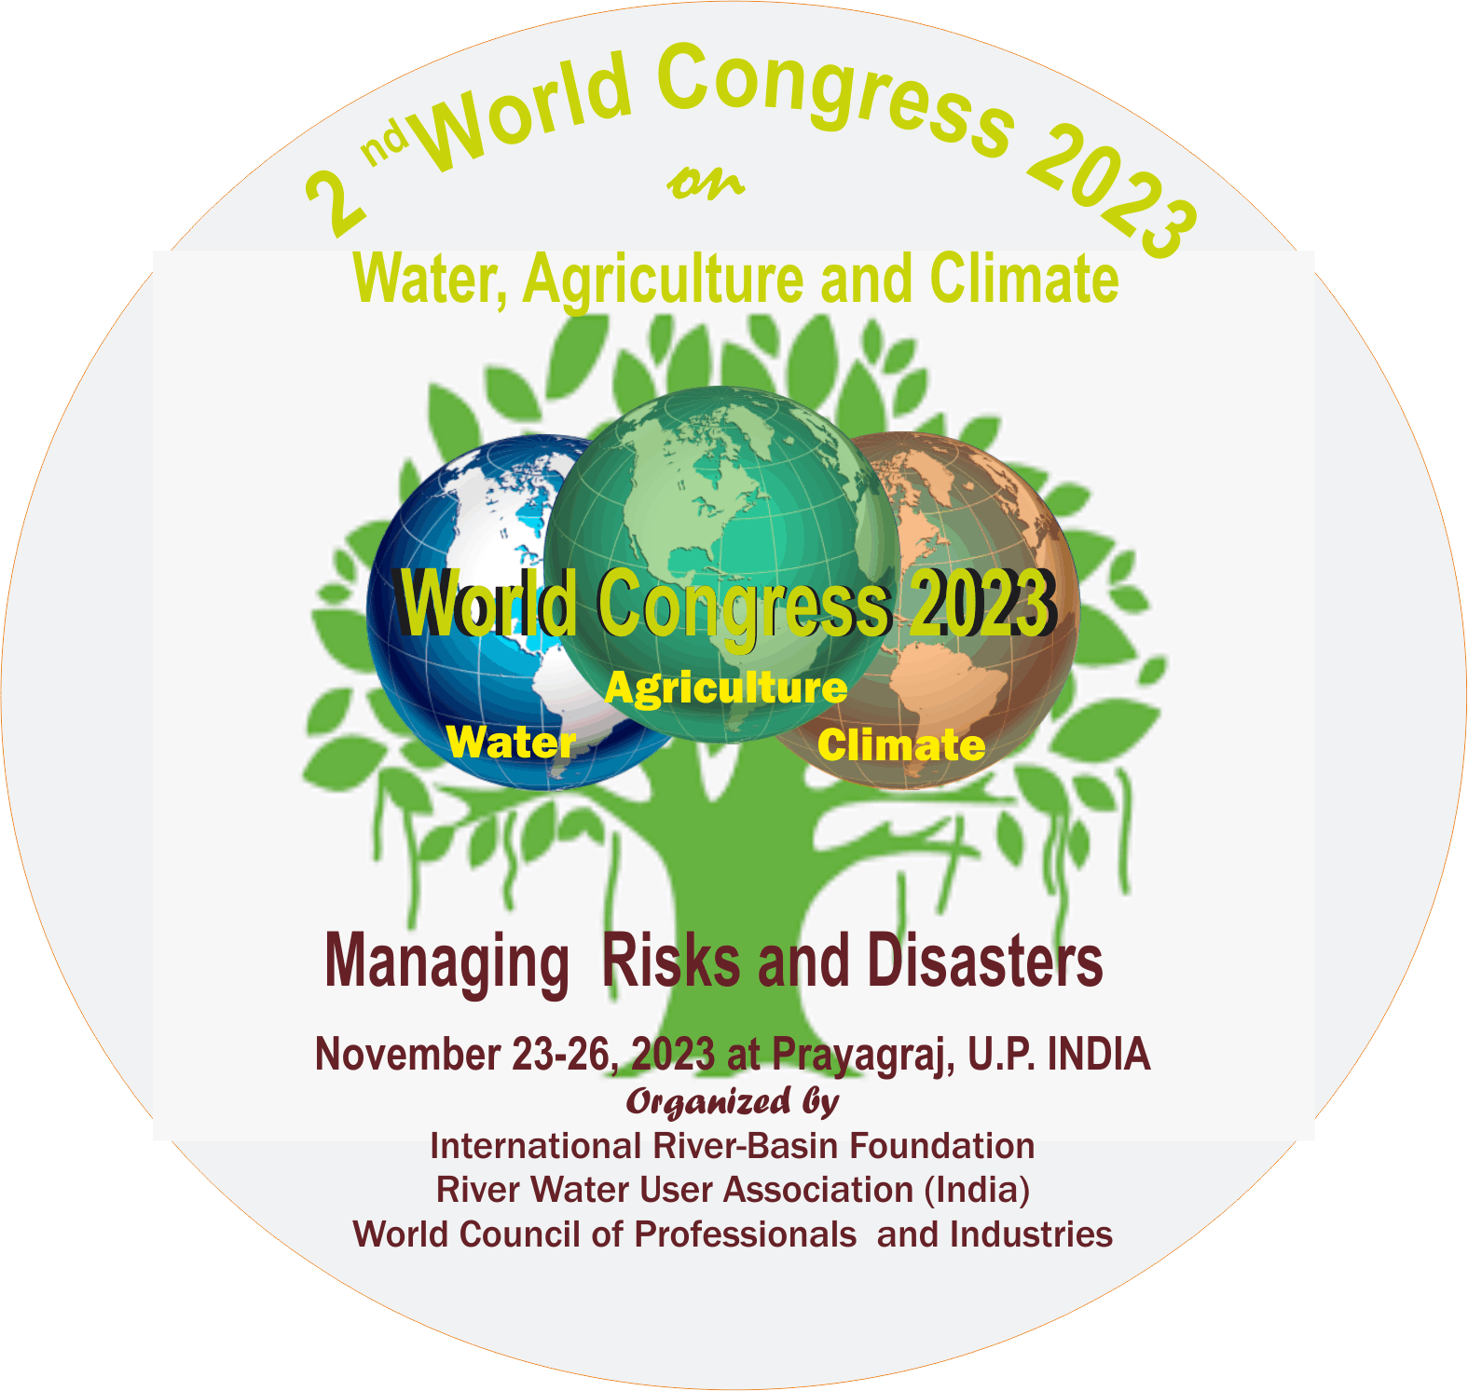 | 2nd World Congress on Water, Agriculture and Climate  Managing Risk and Disasters: Building Resilience for a Sustainable Future  November23-26, 2023 Allahabad, U.P., India  Organized by River Water User Association, India. International River-Basin Foundation-WCPI
PRESENTATION ABSTRACT TEMPLATE
Preferred Type of Presentation: Online/ in person (Select by striking other)
THEMES & TITLE
Theme:
Sub-theme if any:
Abstract title: (maximum 12 words)

Key words: (provide five key words that best describe your topic, study, geography and/or issues covered)

AUTHOR DETAIL/S (maximum 3 presenters)

Author Name(s) | Affiliation/Institution  Give detailed Name | Email address | Phone
1.
2.
3.
Short Bio (50 – 100 words, for presenters only)

ABSTRACT
Write Title
Over Write, Author, e.g. | R. Mishra¹, P.K. Singh² and M. Murlidharan³
Over Write your details e.g. | ^{1.} Principal Scientist, Water Technology Center, ICAR, New Delhi, India  ^{2..} Professor, G.B.P.U.A.T, Pant Nagar, U.P., India  ^{3.} Assistant Professor, SHIATS, Allahabad, U.P., India
 | Abstract
Write Short Abstract (150 to 300 words) | Your abstract should outline the content of your proposed presentation or session. It may include information such as methodology, the issues covered, how they relate to the theme of the conference, how they advance knowledge on any particular topic, any case studies included and any outcomes, innovations or recommendations that come from your paper or session.  .
 | Keywords:

Please save Word Document with file name such as: WC2023Abs_ Last name First initial.doc
(e.g. WC2023Abs_Mishra R.doc)

Instructions:
- Acceptance will be sent to your email after selection by review committee.
- All submission should be done at the email given at the top of this page.
- First. Author. Will be corresponding author, otherwise indicate

Please ensure to reference additional authors who may not necessarily be presenting

